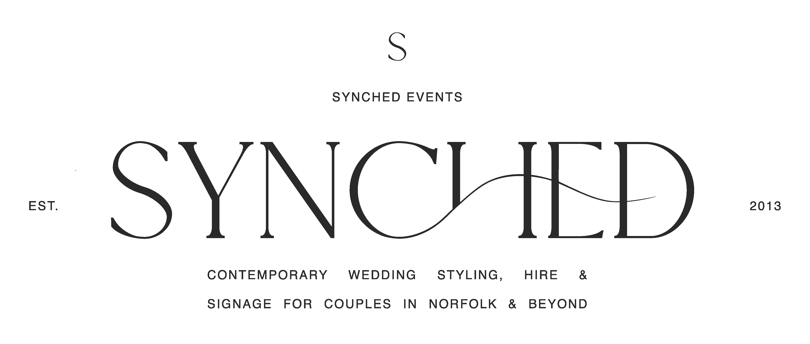

Synched Events - Terms and Conditions

Please read, sign and return this form to us upon booking. Thankyou for choosing to work with Synched Events.

H I R E

Please do double check everything looks correct on your invoice, it is your responsibility to check everything is listed there for you as we will deliver from this list for you.
A 20% non-refundable deposit of the total is due to secure the items and the rest is payable 2 weeks before the wedding. I'll confirm I've received payment by email.
Please provide your mobile and home address should we need to be in touch before or after the wedding.
By confirming your order with us you agree to all our terms of hire here and therefore will pay for damage and loss of items after the event at the prices stated on your invoice within 14 days after the event.
No items can be removed from your invoice within the 14 days of your event date.
Please ensure all props and hire items are checked upon delivery/arrival to venue; or on collection from LLHQ, within two hours to confirm that your whole order is present and correct. If there are any pieces missing we can look to rectify this as soon as possible, but out-of-hours return trips aren't always possible.
Outdoor Items cannot be refunded if not used due to poor weather.
Props can all be used outdoors, but rugs and soft furnishings must not be left to get saturated in wet weather. If items are returned soaked, there will be a charge for additional cleaning and drying time.
Items should be packed together in the original packaging by yourselves, will all items grouped together at the venue for us (we can agree a collection and return time nearer to your date). Original packaging and storage boxes will be charged for if not returned. Storage boxes are £7.00 each to replace.

S T Y L I N G

You agree to give full creative licence to the Synched Events team to style your wedding, based on previous meetings and communications together. The work will be reflective of the style and quality advertised by Synched Events.

Penny will aim to style your wedding or event personally but if for any reason she isn’t able to make the day, she calls on a team of freelancers who have worked with her previously on set ups and work to the same aesthetic and carry out the work with the same passion and professionalism, being fully briefed on your day.
S I G N A G E
All wording for signage to be sent one month before your event, with the exception of table plans which can be 2 weeks before the wedding.
Our Signage Requirements Form should be clear and include all information for illustrations too on this document as this is where the signage will be written from, not from previous email chains. This must include table layouts for table plans with a point of reference in the room to lay them as you require.

Check for any mistakes with spellings before sending. We will always change obvious spellings, but names are copied exactly as I receive them.

C A N C E L A T I O N

We regret that in the event of cancellation of your order after the booking fee is made, a refund is not possible and cancellation once any monies have been paid during the lead up to the event, no refunds will be made. If cancellations are made within 6 months of your events the following payments will need to be paid 6 months - 50% of your invoice, 3 months 75% of your invoice, 1 month 100% of your invoice.

Synched Events Studio accepts no liability for redress beyond that of a full or partial refund, at our discretion, of any monies paid to us, should events beyond our control prevent our delivering your wedding décor on the appointed day or by the appointed time.

D A T A P R O T E C T I O N

We store client names, contact details and information about your event privately and will not share these with any other business or organisation.

Signed……………………….
Date …………………………

